**Banner Application**

**Deadline March 15, 2025 | Installation May 2025**

Name of Person Submitting Application ______________________________________________

Address __________________________ City, State, Zip ________________________________

Relationship to Veteran ___________________________________________________________

Name of Veteran/Service Member ___________________________________________________

Military Branch __________________________________ Rank (if known) _________________

The banner will display years of service (from _____ to _____) or the name of the war/conflict. Please indicate your preference by completing the following:

Years of Service_____________________ War/Conflict, era of service _____________________

Veteran is **□** Alive **□** Deceased

Veteran’s Connection to Plymouth ___________________________________________________

Please include additional biographical information for your veteran or service member for the booklet (limited to 150 characters) and the website (limited to 500 characters). You may write your information on a separate sheet of paper, in an email, or as a Word document (do not sent in PDF format) to tbarker@shawcm.com.

**PHOTO RELEASE FORM**

I hereby grant the Rotary Club of Plymouth AM permission to use the attached photo, which includes images of me, my relative, or the person sponsored, in the Rotary Club of Plymouth AM Military Veterans Banner Program without payment or other consideration.

Name _______________________________ Signature __________________________________

To apply online visit [bit.ly/vetbannerplyrotam](https://bit.ly/vetbannerplyrotam) or scan the code below.

Applications must include the completed form and a photo of the veteran in uniform.

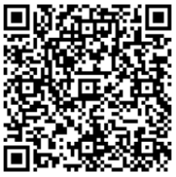

**The Rotary Club of Plymouth AM will review your application and contact you about payment if accepted.**



**MILITARY AND VETERAN**

**BANNER PROGRAM**

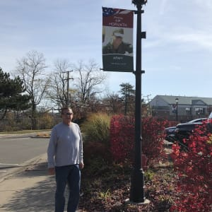

**Recognizing and honoring**

**brave individuals**

**who are serving or have served in the**

**United States Armed Forces**

**Program**

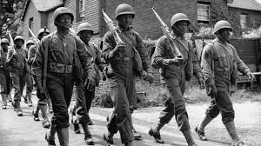

**ROTARY CLUB OF PLYMOUTH AM MILITARY AND VETERAN BANNER PROGRAM**

The Rotary Club of Plymouth AM is proud to present the Military and Veteran Banner program that recognizes and honors those brave individuals who are serving or who have served in the United States Armed Forces. Banners will display a photo of the service person, as well as their name, dates of service, and branch of the United States Armed Forces.

The banner will be hung in downtown Plymouth during the months of May and October/November, to celebrate Memorial Day and Veterans Day, respectively**.**

**Banner Program Qualifications**

To qualify for the Military and Veteran Banner Program, the following criteria must be met: the honoree is an active-duty member of the United States Armed Forces, was an honorably discharged member of the United States Armed Forces, and related to Plymouth, Michigan.

**About the Banner**

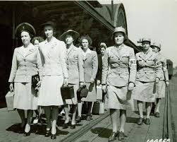

**BANNER STYLE AND DISPLAY**

Each banner is double sided, full color 24" x 48”, and custom designed with an image of the honoree. Upon removal at the end of both Memorial Day and Veterans Day, the banner will be available for pick up and will be eligible to be used the following year.

**Banner Location**

Banners will be located throughout Downtown Plymouth during the months of May and October/November. At this time, we are only allowed to hang 20 banners at a time, so if a spot is not available, we will put you on a waiting list.

**Submission Deadline and Price**

Applicants may choose from one of three contracts:

**1 Year: $250; 2 Years: $400; or 3 Years: $500.** At the end of the contract, the banner is returned to the applicant. At the completion of the program - the first two holidays - the banner will be returned to the applicant, or you may rehang the banner each year. We encourage a yearly donation to help with installing the banners. The deadline for the May 2025 installation is March 1, 2025. Space is limited; we accept submissions on a first-come-first-served basis. If needed, your submission will place you on a waiting list for the November 2026 installation.

**Photo Submission**

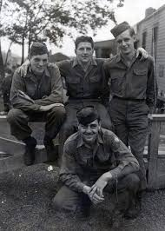

**PHOTO SUBMISSION GUIDELINES**

The photo must show the veteran in uniform, with no exceptions, displayed on the banner (all hard copy photos will be returned). A 5" x 7" digital photo should be saved as a JPG or PNG at a minimum of 600 dots per inch resolution. Email photo to the Rotary at tbarker@shawcm.com. If you do not have a digital photo, please bring a 5" x 7" or larger portrait style photo or mail the photo to The Rotary Club of Plymouth AM’s office and we will digitize the photo and return it to you in an appropriate time frame.

**Proof**

A proof of the banner will be emailed to you to confirm the spelling of the name, branch, years of service or era of service and rank are all correct. If you do not provide an email address you will not have the opportunity to see a proof and therefore forfeit that opportunity. However, the Rotary staff will compare banner proof to application to ensure accuracy. Please make sure your application is correct. Submit photo to Rotary Club of Plymouth AM, PARC – Plymouth Arts and Recreation Complex, 650 Church St., Plymouth, MI 48170.